EVENT DESCRIPTION SHEET
(To be filled in and uploaded as deliverable in the Portal Grant Management System, at the due date foreseen in the system.
Please provide one sheet per event (one event = one workpackage = one lump sum).)
PROJECT
Participant: | 1 - VASKUT NAGYKOZSEGI ONKORMANYZAT (VASKUT)
PIC number: | 921041967
Project name and acronym: | Multifaceted rural Europe — Multifaceted

EVENT DESCRIPTION
Event number: | WP1
Event name: | Town twinning meeting in Vaskut
Type: | Kick-off meeting, Plenary session, Workshop,
In situ/online: | in-situ
Location: | Vaskút, Hungary
Date(s): | 30.06.2023, 01.07.2023, 02.07.2023
Website(s) (if any): | http://www.vaskut-nagykozseg.hu/
Participants
Female: | 62
Male: | 45
Non-binary: | 0
From country 1 - Slovakia: | 54
From country 2 - Germany: | 33
From country 3 - Romania: | 20
Total number of participants: | 107 | From total number of countries: | 3
Description
Provide a short description of the event and its activities.
Project intended to encourage citizens for twin towns to express their rights, broaden their perspective and develop a sense of European belonging and identity. Citizens from municipalities strengthened their partnerships and fostered their cooperation and cultural links.
The Project fostered gender equality issues and non-discrimination considerations, by implementing ethical principles and EU values, as well as gender equity and the exclusion of all forms of discrimination interwoven throughout whole meeting.
The direct target group (municipality, civil society, business representatives, decision-makers, rural producers, youth groups, etc.) took part in the activities.
The indirect target group was the rural residents who participate as visitors or hear about the results of the project from acquaintances.
On the first day, a joint Kick-off meeting was held where they introduced themselves and their view about actual happenings in EU.
On the second day, a large-scale Plenary session was held on the future of Europe and the impact of the Covid 19 pandemic on the local communities.
They shared the European experiences and explored in depth themes that offer the opportunity to build a stronger Europe.
- Utilization of gender equality and non-discrimination principles, rights and responsibilities among citizens.
- Future of Europe, which was dissected from the pro and the contra sides and everyone was given the opportunity to defend their views with via arguments.
In the afternoon, delegations took part in a workshop to summarize the results of the morning's work and draw the conclusions needed to strengthen a sense of belonging to the EU.
In the evening, there was a cultural program.
The closing event of the project took place on the third day and proceeded to disseminate the results of the project.
IMPACT:
Bringing together people from different European countries, foster communication and debate on equal level can be considered as short effects of the project. This is the first fundamental achievement in such crisis situation where assembly and freedom of movement was limited. The full implementation of the planned programs and activities is also considered a success. Members of the delegations can participate on activities; introduce their views, ideas as well as cultural heritages and linguistic richness.
Promoted equity, social cohesion and active citizenship will be the mid- and long term effect of the event. Exchanged best practices and experiences, lessons learned will lead to mutual understanding and create cooperation and friendships among citizens from different countries. Another long-term dimension is embodied in the way people think. The aim is to communicate the outcome of the meeting to a broader audience on positive thinking about the future of EU democracy, because this is the only way to achieve the desired effect: strengthen the welfare society and increasing sense of belonging to the EU. These goals can be achieved with the help of individual interest protection organizations and civil initiatives. Building from the bottom up, the project will deliver results in the medium and long term.

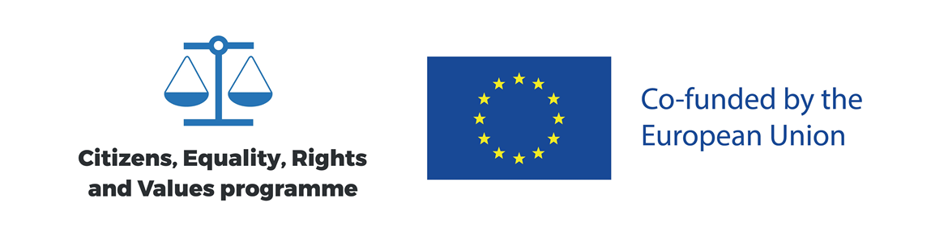
PROJECT NAME: European values are our common future
ACRONYM: EVCF
PROJECT No.: 101089761
AGENDA
Location: Vaskút, Hungary

Day 1. (30.06.2023.)
16:00 – 17:00 | Receiving and registering participants
17:10 – 19:00 | Kick-off meeting
20:00 | Dinner

Day 2. (01.07.2023.)
09:00 – 09:30 | Registration
09:30 – 12:00 | Plenary session  Future of Europe and the impact of the Covid 19 pandemic on the local communities  Utilization of gender equality and non-discrimination principles, rights and responsibilities among citizens.  Future of Europe
12:00 – 13:00 | Lunch break
14:00 – 15:30 | Summarizing workshop
16:00 – 19:00 | Cultural programs
19:00 | Dinner

Day 3. (02.07.2023.)
09:30 – 10:00 | Registration
10:00 – 12:00 | Closing event
12:00 – 13:00 | Lunch

